
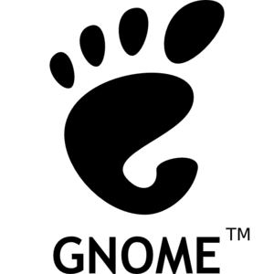

Gold Sponsor



Silver Sponsors







Other Sponsors



Media Partners



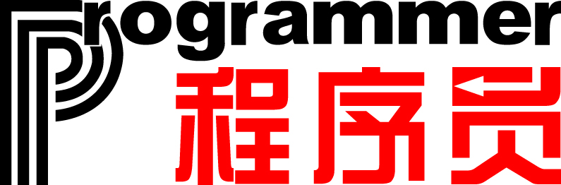

Bronze Sponsor



