EchoNum Program Testing
Execution Environments)
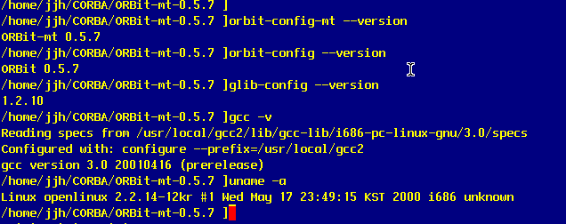
1) server side
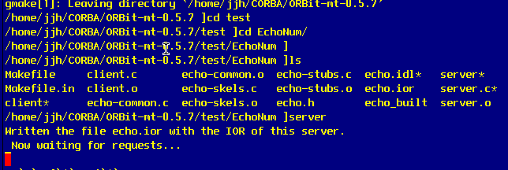

2) client side
client –i 1 –t 10 /* 10 threads */
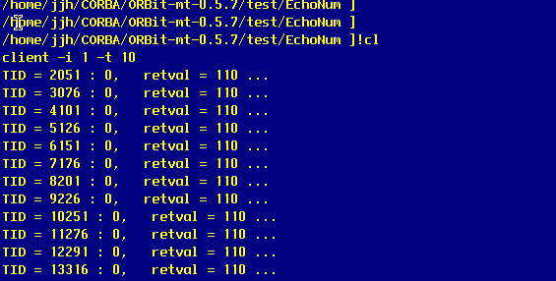

3) top utility
start point :
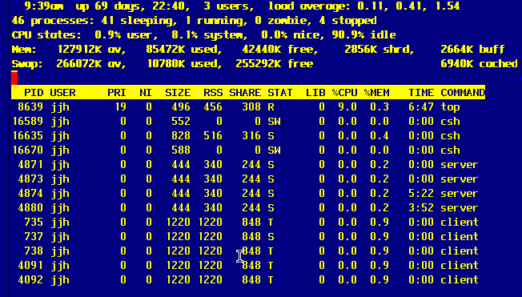
At 09:39 am
client image size : 1220KB
server image size : 444 KB

after 10 minutes :
At 09:49 am
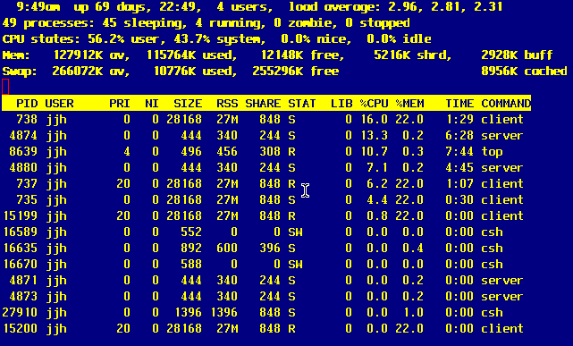
client image size : 27MB
server image size : 444 KB

Consequently, client size was bigger, performance was down.

